Sacred Heart Primary Cyber Incident Reporting

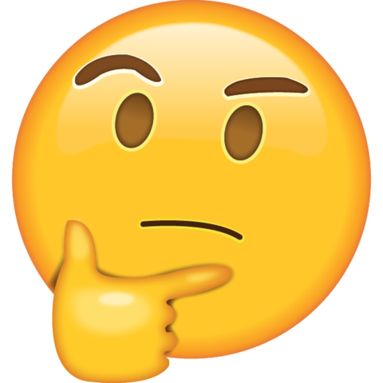  Is That Ok? | 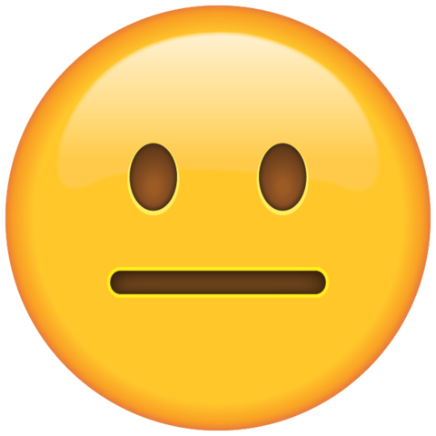  Something is Wrong | It’s really bad,  I need HELP!
Concern:  - Did you see something that you’re not sure is OK?  - Are you not sure if you should tell someone?  - Have you seen or heard something online that is upsetting you or somebody else? | Concern:  - I’ve seen something and I don’t like it.  - I’m pretty sure someone will get hurt by this.  - I need help deciding what to do next. | Concern:  - Urgent, I really need help!  - It’s only going to get worse until something is done.  - Someone I don’t know is continually contacting me
Examples :  - People saying bad things about you or somebody else online  - Inappropriate languages or images online  - A friend has told personal details online or has a public account  - Someone is posting inappropriate memes that make me uncomfortable  - You think it might be someone else in a group chat | Examples:  - Someone online is encouraging you or somebody else to do something wrong  - Repeated unwanted contact from someone  - Someone has posted something inappropriate using my name or my photo  - Someone is continually commenting on my posts or tagging me in inappropriate content  - Harassment  - Anonymous messages that are inappropriate  - Someone has hacked my account | Examples:  - Someone else knows my password and they’re using my account  - Continuous posting of mean things or inappropriate pictures  - Someone is asking you to send photos of yourself or give out personal information  - Someone online is asking me (or a friend) to meet up in person and not tell anyone.  - Someone is making threats on social media  - Blackmail threats (constant)  - Stalking  - Someone forcing you to do the wrong thing
If this matches any of your worries  REPORT HERE | If this matches any of your worries  REPORT HERE | If this matches any of your worries  REPORT HERE

